
School of Sciences | Department of Computer Science and Engineering

Replace this with the title of the thesis

Replace this with the subtitle (if applicable, if not delete the line)

Master of Science
in enter your discipline

Enter you name here

© Enter the month and year you are submitting

Acknowledgements

Abstract
Write this last and remember what it is about = To provide a brief statement (no more than 1 page long) regarding the work performed. The statement should not go into too many specifics but should provide the reader with enough information to have a good idea of what the project is about.)

Table of Contents
Acknowledgements 2
Abstract 3
Table of Contents 4
1 Introduction 6
1.1 Overview 6
1.2 Aims and objectives 6
1.3 Structure of thesis 6
1.4 Summary 6
2 Project Scope 7
2.1 Introduction 7
2.2 Title 1 7
2.3 Title 2 7
2.4 Title 3 7
2.5 Summary 7
3 Analysis and Design 8
3.1 Introduction 8
3.2 Title 1 8
3.3 Title 2 8
3.4 Title 3 8
3.5 Summary 8
4 Implementation and Testing 9
4.1 Introduction 9
4.2 Title 1 9
4.3 Title 2 9
4.4 Title 3 9
4.5 Summary 9
5 Conclusions and Future Work 10
5.1 Introduction 10
5.2 Title 1 10
5.3 Title 2 10
5.4 Title 3 10
5.5 Summary 10
Bibliography 11
Appendices 12
Appendix A 12
Appendix B 13
Appendix C 14
Installation Manual 15
Requirements 15
Installation procedure 15
Configuration 15
User Manual 16

Introduction

Overview
Understanding the formation and evolution of galaxies at high redshifts is a fundamental objective in astrophysics. High-redshift galaxies, observed as they were billions of years ago, provide crucial insights into the early stages of the universe, including the initial burst of star formation, the buildup of galactic structures, and the growth of supermassive black holes. Observational data from space-based telescopes, such as the Hubble Space Telescope and the recently launched James Webb Space Telescope (JWST), have advanced our understanding of these early cosmic epochs. However, the inherent challenges of observing distant galaxies, including their faintness, dust obscuration, and the limited wavelength range of available instruments, mean that much of this epoch remains poorly understood.
To address these limitations, machine learning, and particularly deep generative models, have emerged as powerful tools for extrapolating and simulating the properties of galaxies based on available data. Generative Adversarial Networks (GANs) and Diffusion Models have proven effective in generating synthetic data that closely resembles real-world observations. These models enable researchers to predict missing information, simulate various scenarios, and explore the conditions of the early universe in a controlled, computational environment.
Diffusion models, a class of probabilistic generative models, offer significant advantages over traditional GANs. By gradually transforming random noise into structured data, they have shown superior stability during training and better coverage of the underlying data distribution, as highlighted in recent studies on time-series forecasting and image generation​(2401.03006v2)​(2209.00796v13)​(2105.05233v4). Their ability to generate high-fidelity outputs with more robust training dynamics makes them a promising tool for simulating high-redshift galaxy formations, filling gaps left by observational limitations, and improving our understanding of early galaxy evolution.
This thesis aims to explore the application of diffusion models in predicting and reconstructing the spectral energy distributions (SEDs) of high-redshift galaxies, comparing their performance with GANs. By leveraging advanced deep learning techniques, this study seeks to generate accurate synthetic spectra, enhancing our ability to study galaxies that are otherwise difficult to observe directly.

Aims and objectives
The primary aim of this thesis is to develop and evaluate the effectiveness of diffusion models for generating synthetic spectral data of high-redshift galaxies. This involves creating a model capable of producing realistic and high-fidelity spectra that reflect the physical properties of galaxies in the early universe. A secondary aim is to conduct a comparative analysis between diffusion models and GANs, focusing on their ability to generate accurate and diverse galaxy spectra, as well as their training efficiency and stability.
The specific objectives of this thesis are as follows:
- Design and implement a diffusion model tailored for generating synthetic galaxy spectra based on multi-wavelength observational data.
- Train and validate the diffusion model using existing datasets, ensuring it can accurately replicate known spectral properties and predict missing information.
- Develop a GAN-based model to serve as a benchmark for evaluating the performance of the diffusion model.
- Conduct a comparative analysis of the two models, focusing on metrics such as fidelity, diversity, computational efficiency, and robustness.
- Interpret the results to determine the strengths and limitations of each approach and provide insights into the most effective generative model for astrophysical applications.

Structure of thesis
The thesis is structured as follows:
- Introduction: Provides an overview of the research context, the importance of studying galaxy formation at high redshifts, and the role of generative models in addressing data limitations. It also states the thesis objectives and outlines the structure of the document.
- Literature Review: Reviews current theories and findings related to galaxy formation and evolution at high redshifts. It also surveys existing generative models, such as GANs and Diffusion Models, and their applications in various domains, with a focus on astrophysical research. Previous works leveraging generative models to reconstruct and predict galaxy spectra are discussed in detail.
- Theoretical Background: Introduces the mathematical foundations of diffusion models, covering key concepts like denoising diffusion probabilistic models (DDPMs) and Score-Based Generative Models (SGMs). It also explains GAN architectures and common challenges, along with an introduction to astrophysical concepts relevant to the study, such as spectral energy distributions and multi-wavelength data.
- Methodology: Describes the datasets used in the study, including preprocessing techniques and data augmentation strategies. It details the design and implementation of the diffusion model, parameter tuning, and training procedures. The GAN architecture is presented as a baseline, and the evaluation metrics used for comparison are outlined.
- Experimental Results: Presents the performance results of the diffusion model and GAN, including both quantitative metrics and qualitative visual comparisons. Specific case studies are highlighted to demonstrate the strengths of each model.
- Discussion: Interprets the experimental findings, discussing the implications for future research in galaxy formation and generative modeling. It addresses the strengths and weaknesses of the models, identifies potential areas for improvement, and suggests future research directions.
- Conclusion and Future Work: Summarizes the key contributions of the thesis, reaffirming the advantages of diffusion models for astrophysical applications. It also proposes future research directions, including model enhancements and broader applications in other areas of astrophysics.
- References: Lists all academic literature, datasets, and software tools cited throughout the thesis.
- Appendices: Provides additional figures, tables, technical details, and supplementary materials that support the main content of the thesis.

Summary
This introduction has outlined the motivation, aims, and objectives of this thesis, which focuses on the application of diffusion models to simulate and predict the properties of high-redshift galaxies. By developing a robust generative model that can generate accurate synthetic spectra, this research seeks to fill gaps in observational data and enhance our understanding of galaxy formation during the early epochs of the universe. The thesis will also provide a detailed comparative analysis between diffusion models and GANs, highlighting the advantages and limitations of each approach, and ultimately contributing to the advancement of generative modelling techniques in astrophysics.

Project Scope

Introduction
The scope of this project is to investigate the use of diffusion models for generating synthetic spectral data of high-redshift galaxies and to perform a comparative analysis with Generative Adversarial Networks (GANs). Given the challenges of observing distant galaxies—such as faintness, dust obscuration, and limited wavelength coverage—the project aims to leverage machine learning techniques to address these limitations by generating accurate synthetic spectra. The study focuses on the design, development, and evaluation of these generative models, with the goal of improving our understanding of galaxy formation in the early universe. This chapter details the specific components of the project, the processes involved, and the expected outcomes.

Development and Implementation of Diffusion Models
A significant part of this project is the development and implementation of diffusion models specifically tailored to generate high-fidelity synthetic spectra for high-redshift galaxies. This involves designing an appropriate model architecture that can effectively learn from multi-wavelength observational datasets. The model development process includes preparing the data, which entails collecting spectral energy distributions (SEDs) from various telescopic surveys and handling typical astrophysical data challenges, such as missing data points.
The training and optimization of the diffusion model are essential to ensure it can accurately replicate observed galaxy spectra and extrapolate missing information. Advanced machine learning techniques will be employed to optimize the model’s performance, including tuning hyperparameters for better accuracy and stability. The goal is to develop a robust generative model that can simulate the physical properties of galaxies, thus providing a valuable tool for researchers to predict and analyze galaxy characteristics that are otherwise difficult to observe directly.

Benchmarking with Generative Adversarial Networks (GANs)
In addition to developing a diffusion model, this project involves creating a benchmark using a GAN-based approach. This will provide a standard for comparing the performance of the diffusion model. The GAN architecture will be adapted from existing models proven effective in related fields, with modifications to accommodate the specific requirements of generating spectra for high-redshift galaxies.
Training the GAN model will involve similar processes as the diffusion model, ensuring that it is trained on the same datasets to maintain a consistent basis for comparison. The evaluation will focus on common issues associated with GANs, such as mode collapse and training instability, to highlight how these challenges impact performance. Through this comparison, the project will assess key performance indicators like fidelity, diversity, and computational efficiency, providing a clear understanding of each model's strengths and limitations.

Evaluation Metrics and Experimental Analysis
A thorough evaluation of both the diffusion model and the GAN is crucial to this project. The evaluation process begins with the selection of appropriate metrics to assess the quality of the generated spectra. Metrics such as Mean Squared Error (MSE), Mean Absolute Error (MAE), and Continuous Ranked Probability Score (CRPS) will be used to quantify the models' performance. Additionally, visual assessments will be conducted to compare the synthetic spectra against real observational data, allowing for a more nuanced understanding of each model's ability to replicate real-world patterns.
The project involves designing a comprehensive experimental setup to test the models under various conditions. Experiments will include training the models on different datasets, adjusting noise levels, and applying data augmentation techniques to evaluate the robustness and generalizability of the models. Specific case studies will be used to demonstrate the practical utility of the models, such as predicting missing data in known galaxy spectra or simulating the spectral energy distributions of hypothetical high-redshift galaxies. These scenarios will illustrate how the models can be applied to real-world problems in astrophysics, providing insights that can guide future research and observational strategies.

Summary
This chapter has outlined the scope of the project, emphasizing the development, implementation, and evaluation of diffusion models for generating synthetic spectra of high-redshift galaxies. The project also involves creating a GAN-based benchmark to provide a comparative analysis. Through comprehensive testing and evaluation, the project aims to determine the most effective generative model for astrophysical applications, thereby enhancing our ability to study galaxies in the early universe. The outcomes of this research will contribute to the broader field of astrophysics by offering new methods to simulate and analyze galaxy properties that are otherwise challenging to observe directly.

Analysis and Design

Introduction
The analysis and design phase is fundamental to the successful development of generative models that can accurately transform photometric data into spectrometric data for high-redshift galaxies. This process involves a detailed understanding of the data characteristics, the design of suitable architectures for both diffusion models and GANs, and the implementation of effective training strategies. The goal is to ensure that the models can learn the complex relationships between photometric inputs and the desired spectrometric outputs, thereby enabling accurate and reliable simulations of galaxy spectra. This chapter discusses the data preparation methods, the design considerations for the models, and the key architectural choices that guide their development.

Data Analysis and Preparation
The initial step in this project involved generating the dataset using a specialized library. By applying specific filters, photometric data was obtained for a set of high-redshift galaxies. Photometry, which measures the total light from a galaxy across various wavelength bands, provides a broad view of its properties but lacks the detailed spectral information that can reveal underlying physical processes. The core objective of this thesis is to bridge this gap by developing models that can transform these photometric measurements into detailed spectrometric data, which contain finer information about the galaxy's composition, age, and physical conditions.
Data preparation included the careful selection and application of filters to ensure that the photometric data captured essential features relevant to spectrometric transformations.

Observed Wavelength λ (μm) | Rest Wavelength λ (μm)
0.14356764 | 0.433
0.1969496 | 0.594
0.2556366 | 0.771
0.29376658 | 0.886
0.41611405 | 1.255
0.54907161 | 1.656
0.71717506 | 2.163
1.18103447 | 3.562
1.4960212 | 4.512
1.88527849 | 5.686
2.63129971 | 7.936
7.9575596 | 24
23.20954882 | 70
29.84084849 | 90
53.05039731 | 160
82.89124579 | 250
116.04774411 | 350

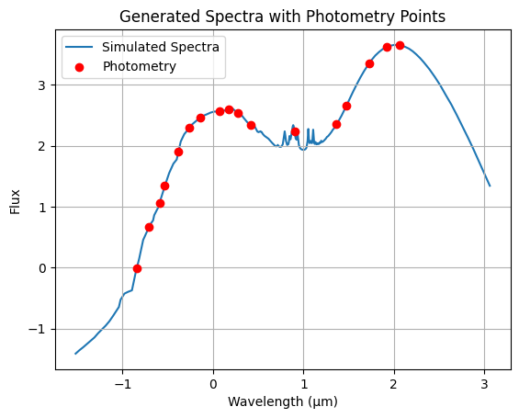

This step was crucial for creating a dataset that could effectively train the generative models. Additionally, preprocessing steps were applied to clean the data, normalize inputs, and handle any inconsistencies. Ensuring the data was well-prepared allowed the models to learn robust mappings from photometry to spectrometry, enabling them to predict spectral energy distributions (SEDs) with higher fidelity.

Diffusion Model Architecture Design
A major focus of the design phase was the development of a diffusion model architecture specifically adapted to generate detailed spectrometric data from photometric inputs. Diffusion models, known for their strong generative capabilities, are particularly well-suited for tasks involving complex data distributions due to their progressive noise refinement process. This process, central to denoising diffusion probabilistic models (DDPMs), consists of a forward step that perturbs the data into noise and a reverse step that reconstructs the data from noise.

Diffusion Process Explained
The forward diffusion process involves gradually adding noise to the data , transforming it through a Markov chain into a noise-like variable . Formally, this is represented as:

$$q\left(x_{1:T} | x_{0}\right)=\prod_{t=1}^{T}{q\left(x_{t} | x_{t-1}\right)},$$
$$q\left(x_{t} | x_{t-1}\right)=N\left(x_{t};\sqrt{1-β_{t}}x_{t-1},β_{t}Ι\right),$$

Where $β_{t}$ denotes the variance of the noise at each time step. To directly sample from the distribution $q(x_{t}|x_{0})$, the relationship is simplified as:

$$x_{t}=\sqrt{\overline{a_{t}}}x_{0}+\sqrt{1-\overline{a_{t}}}ϵ, ϵ\sim N\left(0,I\right),$$

With $a_{t}=1-β_{t}$ and $\overline{a_{t}}=\prod_{i=1}^{t}{a_{i}}$. This step progressively perturbs $x_{0}$ until the data distribution becomes indistinguishable from Gaussian noise, approximated by $q(x_{T})≈N\left(0,I\right)$.
The reverse process aims to reconstruct the original data by iteratively denoising $x_{T}$ back to $x_{0}$. It is parameterized by a learned distribution:

$$p_{θ}\left(x_{t-1} | x_{t}\right)=N\left(x_{t-1};μ_{θ}\left(x_{t},t\right),σ_{t}^{2}I\right),$$

Where $μ_{θ}$ and $σ_{t}$ are predicted by a neural network conditioned on $x_{t}$ and time step $t$.

The expression for is given by:

$$μ_{θ}\left(x_{t},t\right)=\frac{1}{\sqrt{a_{t}}}\left(x_{t}-\frac{β_{t}}{\sqrt{1-\overline{a_{t}}}ϵ_{θ}\left(x_{t},t\right)}\right),$$
where $ϵ_{θ}$ is trained to match the true noise $ϵ$. The training objective for this denoising network minimizes the weighted mean squared error:

$$L_{simple}=E_{x_{0},ϵ,t}\left[{\left\|ϵ_{θ}\left(x_{t},t\right)-ϵ\right\|}^{2}\right].$$

Application to Spectrometric Data Generation
In this project, the diffusion model was adapted to handle the unique characteristics of spectrometric data by incorporating mechanisms that capture wavelength correlations. Given that spectrometric data possess dependencies across different wavelengths, the architecture was designed to include specialized layers capable of modeling these relationships.
Noise schedules, which dictate how noise is added at each forward step, were finely tuned to ensure a balanced transformation from coarse, noisy approximations to refined, high-fidelity outputs. The reverse process then iteratively refined these approximations, guided by a loss function that minimized discrepancies between generated outputs and real spectrometric observations.
During training, the model learned to accurately generate spectra from photometric inputs by minimizing this objective over multiple epochs. The trained model demonstrated the ability to synthesize spectra with characteristics matching real observational data, effectively bridging photometric and spectrometric representations.
By employing this diffusion-based approach, the project leveraged the strengths of DDPMs in reconstructing complex, high-dimensional data, ensuring that generated spectra retained crucial features and correlations across wavelengths, thus enabling precise predictions from new photometric data.

Generative Adversarial Network (GAN) Architecture Design
In parallel, a Generative Adversarial Network (GAN) was designed to serve as a benchmark for evaluating the performance of the diffusion model. The GAN consists of two components: a generator that attempts to produce realistic spectrometric data from photometric inputs, and a discriminator that assesses the quality of these generated spectra by comparing them to real observations. Through this adversarial setup, the generator learns to improve its outputs over time.

Generative Adversarial Network (GAN) Framework

A GAN comprises a generator $G$ and a discriminator $D$, which are trained in opposition to each other. The objective is to optimize the following min-max game:

$$\begin{matrix}min \\ G\end{matrix} \begin{matrix}min \\ D\end{matrix}E_{x\sim p_{data}}\left[logD\left(x\right)\right]+E_{Z\sim P_{Z}}[\log\left(1-D\left(G\left(z\right)\right)\right)]$$

where:
- $p_{data}$ represents the distribution of real spectral data.
- $p_{z}$ is the distribution of noise input $z$ fed into the generator.

The generator maps a noise vector $z$ to synthetic spectral data $G(z)$. The discriminator outputs the probability that a given data sample is real or generated, helping refine the generator’s output through feedback.
To address the specific challenges of spectral data generation, techniques such as spectral normalization and auxiliary losses were incorporated, stabilizing training and enhancing the diversity of the generated spectra.

TimeGAN Extension with Embedding and Recovery Functions

The design of the GAN was further enhanced by incorporating principles from TimeGAN, which adapts GANs for time-series data to maintain temporal dynamics. TimeGAN includes embedding and recovery functions that map between the original feature space and a latent space, facilitating efficient adversarial training. The Embedding Function $e$ maps input photometric data $\left(s,x_{1:T}\right)$ to latent representations $(h_{s},h_{1:T})$:
$$h_{s}=e_{s}\left(s\right), h_{t}=e_{X}\left(h_{S},h_{t-1},x_{t}\right)$$
where $e_{S}$ is the static embedding network and $e_{X}$ is the temporal embedding network, typically implemented with recurrent architectures.
The Recovery Function $r$ reconstructs the original data from latent space:
$$\tilde{s}=rs\left(h_{s}\right), \tilde{x_{t}}=r_{X}\left(h_{t}\right)$$
This ensures that the embedded data can be accurately mapped back to the original space, maintaining high fidelity in the generated outputs.

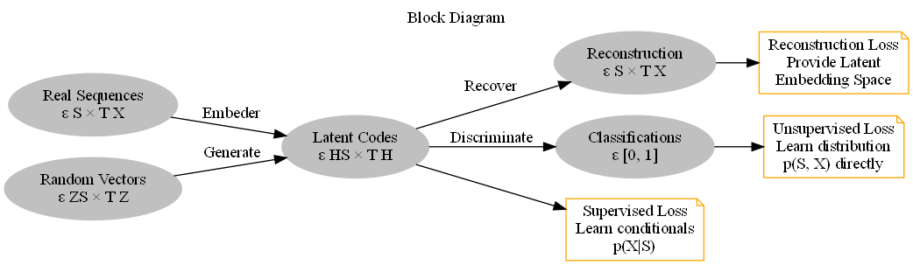
Figure : Block diagram of component functions and objectives.

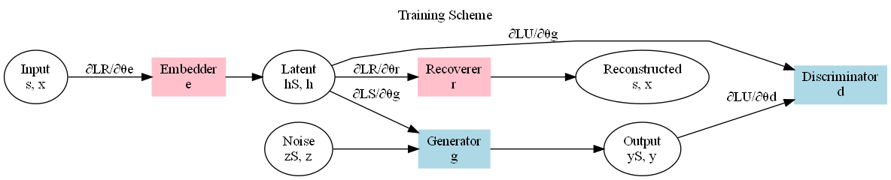
Figure : Training scheme indicating the forward propagation of data and the backpropagation of gradients

Loss Functions in TimeGAN
TimeGAN optimizes three key losses that play a pivotal role in training the network effectively. The first is the Reconstruction Loss $L_{R}$, which ensures that the embedded data can be accurately recovered from the latent space. This loss is defined as:
$$L_{R}=E_{s,x_{1}:T\sim p}\left[{\left\|s-\tilde{s}\right\|}^{2}+\sum_{t=1}^{T}{{\left\|x_{t}-\tilde{x_{t}}\right\|}^{2}}\right]$$
The reconstruction loss enforces the model to accurately map the input data to latent space and back, preserving key features and minimizing reconstruction errors.
The second key loss is the Unsupervised Adversarial Loss $L_{U}$, which functions similarly to the traditional GAN loss and guides the generator to produce realistic outputs. It is defined by the expression:
$$L_{U}=E_{s,x_{1}:T\sim p}[\log{(1-D(h_{s},h_{1:T}))] }$$
This loss encourages the generator to create data that the discriminator cannot distinguish from real data, thereby enhancing the realism of the generated outputs.
The third loss is the Supervised Loss $L_{S}$, which guides the generator to learn stepwise temporal transitions. This loss helps the model understand the progression of data over time and is given by:
$$L_{S}=E_{s,x_{1}:T\sim p}\left[\sum_{t=1}^{T}{{\left\|h_{t}-g_{X}\left(h_{S},h_{t-1},z_{t}\right)\right\|}^{2}}\right]$$
By incorporating this loss, the generator learns to maintain consistency in temporal patterns, allowing it to generate data that follows realistic time-based dependencies.
These loss components collectively ensure that the generator in TimeGAN not only captures complex temporal dependencies but also produces spectrally realistic and coherent data. By integrating reconstruction, unsupervised adversarial, and supervised losses, the model is equipped to generate high-quality data that aligns with the characteristics of the training set.

Summary
This chapter has outlined the key components of the analysis and design phase for developing models to transform photometric data into spectrometric data for high-redshift galaxies. It began with a discussion on data generation and preparation, explaining how the dataset was created using specialized libraries and filters to obtain relevant photometric information. The design of the diffusion model was then detailed, emphasizing its architecture and training strategy for converting photometric inputs into accurate spectrometric outputs. Finally, the chapter described the development of a GAN architecture as a comparative benchmark, highlighting the unique adaptations made to suit the spectral transformation task. Together, these models form the basis for the experiments and evaluations that will be presented in the following chapters.

Implementation and Testing

Introduction
This section outlines the methodology used in the implementation of generative models for converting photometry data into simulated spectrometry. The aim is to explore and compare the performance of a diffusion-based model and a GAN-based architecture. Both models were designed to leverage innovative neural network structures for effective data synthesis and to evaluate their capabilities in reconstructing accurate spectrometry data from input photometry.

Diffusion Model Architecture
The Time Series Diffusion model is an innovative combination of convolutional layers, residual blocks, and transformer encoders, designed to model the complex relationships inherent in photometry and spectrometry data. The model incorporates a progressive noise schedule to guide the forward and reverse diffusion processes.
Key Components of the Diffusion Model
The architecture of the diffusion model consists of multiple core elements, which are designed to enhance the process of forward and reverse diffusion:

- Initial Convolution Layer: Extracts initial features from the input photometry data.
- Residual Blocks: Improve feature propagation and enable deeper network structures without degradation.
- Transformer Layer: Captures long-range dependencies and enhances sequence modeling.
- Noise Schedule: Implements a structured noise schedule for gradual diffusion.

The TSDiff model, inspired by advancements in probabilistic time-series forecasting from the NeurIPS 2023 paper on self-guiding diffusion models, was designed to handle complex data relationships with an innovative combination of convolutional layers, residual blocks, and transformers. By leveraging noise scheduling and forward diffusion processes, the TSDiff model introduces progressive noise into input data and refines it through denoising to reconstruct high-fidelity outputs.
The initial convolution layer extracts preliminary features from the photometry data, which is then passed through a series of residual blocks. These residual blocks help maintain gradient flow, making training deeper networks more effective. The transformer layer captures long-range dependencies, crucial for modeling temporal and sequential relationships inherent in photometry data. The final output layer ensures that the processed data is transformed into a format that matches the target spectrometry shape.
The forward diffusion sample function introduces noise according to a predefined schedule, enabling the model to learn to remove noise during the reverse process. The model’s noise scheduling follows principles outlined in diffusion models, ensuring stability and improved performance.
The TSDiff model can be extended with a self-guided mechanism to further refine its output. This self-guidance involves adjusting the noise estimation based on gradients computed from a supervised loss, enabling the model to produce more accurate outputs.
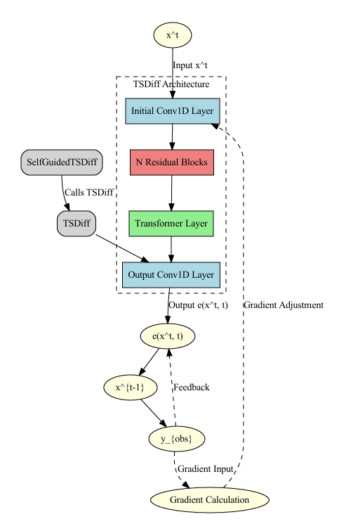

Training and Optimization of the Diffusion Model
The training process for both the TSDiff and SelfGuidedTSDiff models was designed to ensure robust learning and effective generalization. The training strategy began with data preprocessing, where photometry data was normalized and formatted to align with the model's input specifications. This step ensured that the data flowed seamlessly through the convolutional and transformer layers during training.
During the forward diffusion phase, progressive noise was added to the input photometry data at various time steps. This strategic noise injection was essential for training the model to learn the denoising process required to generate clean spectrometry outputs. The noise schedule was carefully designed to balance complexity and stability, allowing the model to reconstruct the original data distribution effectively from noisy inputs.
The Mean Squared Error (MSE) loss function was used as the primary supervised criterion to measure the discrepancy between the generated spectrometry outputs and the real target data. This loss function was chosen for its effectiveness in regression tasks, providing a straightforward metric to assess how accurately the model approximated the true spectrometry values.
Backpropagation played a pivotal role in training, enabling the computation of gradients that guided the parameter updates. The gradients were used to adjust the weights and biases in the network in the direction that minimized the loss function. This process was repeated iteratively across epochs to progressively reduce the model's training loss and improve its ability to generalize to unseen data. The Adam optimizer was selected for its adaptive learning rate capabilities, which contributed to stable and efficient training. By zeroing the gradients at each iteration, the optimizer ensured that previous gradient information did not interfere with the current parameter updates, allowing for more precise and effective learning.

Title 3

Summary

Conclusions and Future Work

Introduction

Title 1

Title 2

Title 3

Summary

Bibliography

Appendices

Appendix A

Appendix B

Appendix C

Installation Manual

Requirements

Installation procedure

Configuration

User Manual

